ELK and DynaTrace

Great — I’ll give you crisp but complete notes so you don’t need a full video. This is exactly how you should explain ELK in interviews.

🎯 What is ELK Stack?
ELK = Elasticsearch + Logstash + Kibana
- Elasticsearch → Storage + search engine
- Logstash → Log processing pipeline
- Kibana → Visualization (UI/dashboard)

🔥 Why Do We Use ELK? (Core Purpose)
👉 Centralized Logging System
Instead of checking logs on multiple servers:
# ❌ Without ELK
ssh server1
cat /var/log/app.log

ssh server2
cat /var/log/app.log
👉 With ELK:
- All logs → one place
- Search → in seconds
- Visualize → dashboards

🧠 Real Production Problem (Very Important)

🔥 Scenario
You have:
- 10 microservices
- Running on Kubernetes
- 50+ pods
👉 Issue occurs:
- API is failing randomly

❌ Without ELK
- Login to each pod
- Check logs manually
- Time consuming
- Hard to correlate

✅ With ELK
👉 You just go to Kibana:
Search:
error OR exception
👉 Instantly see:
- Which service failed
- Timestamp
- Root cause

⚙️ How ELK Works (Flow)

🔁 Step-by-Step Flow
- Applications generate logs
- Logs collected (Filebeat / Logstash)
- Logstash processes logs
- Stored in Elasticsearch
- Visualized in Kibana

🔄 Flow Example
App → Filebeat → Logstash → Elasticsearch → Kibana

🧩 Components Explained Simply

🔹 1. Elasticsearch (Brain)
- Stores logs as JSON
- Fast search engine
👉 Example:
GET logs/_search?q=error

🔹 2. Logstash (Processor)
- Collects logs
- Transforms logs
👉 Example:
- Convert logs to JSON
- Filter fields

🔹 3. Kibana (UI)
- Dashboard
- Graphs
- Search
👉 Example:
- Error count per minute
- CPU usage graph

🔥 ELK in Kubernetes (Real Use Case)

🧠 Scenario
Pods are dynamic:
- Created
- Deleted
👉 Logs get lost ❌

✅ Solution
- Use Filebeat DaemonSet
- Collect logs from all nodes

🚀 Commands
kubectl get pods
kubectl logs <pod-name>
👉 Temporary

👉 With ELK:
# No need to check pod manually
Search in Kibana UI

🎯 Key Benefits (Interview Points)

✅ 1. Centralized Logging
- All logs in one place

✅ 2. Fast Searching
- Search millions of logs instantly

✅ 3. Debugging Made Easy
- Find root cause quickly

✅ 4. Visualization
- Graphs, dashboards

✅ 5. Alerting
- Send alerts on errors

✅ 6. Works with Microservices
- Track logs across services

🔥 Real Interview Scenario Answer
👉
“We use ELK for centralized logging in distributed systems like microservices and Kubernetes. It helps collect logs from multiple services, process them, store them in Elasticsearch, and visualize them in Kibana. This allows quick debugging, monitoring, and root cause analysis.”

⚠️ Problems Without ELK

❌ Logs scattered across servers
❌ Hard to debug production issues
❌ No visibility
❌ Time wasted

🔄 ELK vs kubectl logs
Feature | kubectl logs | ELK
Scope | Single pod | Entire system
History | Limited | Stored long-term
Search | Manual | Powerful search
Visualization | No | Yes

🚀 Bonus: Alternatives (Good to Mention)
- EFK (Fluentd instead of Logstash)
- Loki + Grafana (lightweight)

🎯 Final Interview Answer (Best)
👉
“ELK is used for centralized logging in distributed environments. It collects logs from multiple services, processes them, and stores them in Elasticsearch, allowing fast search and visualization through Kibana. This helps in debugging, monitoring, and analyzing system behavior efficiently.”
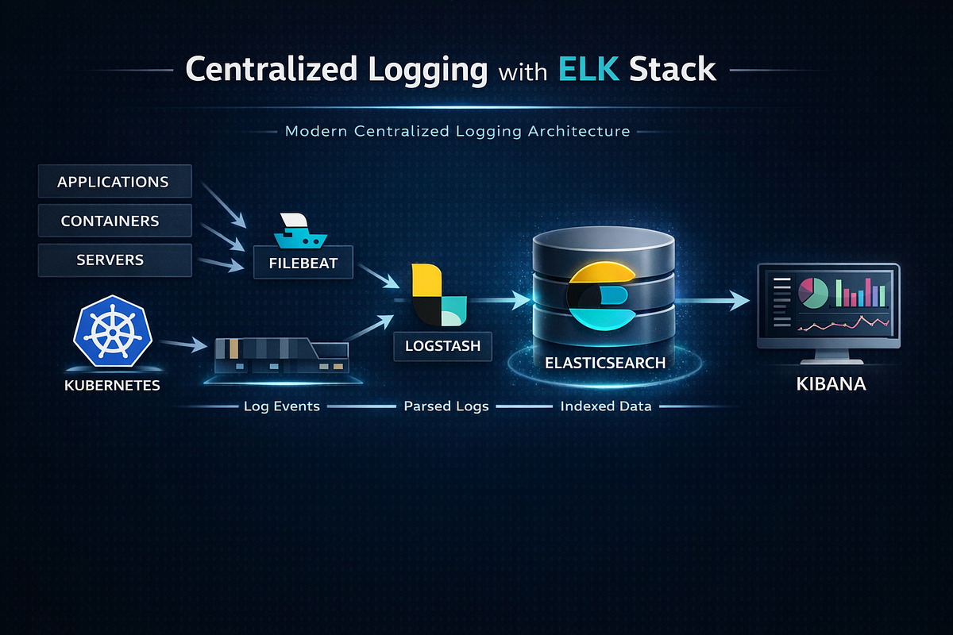

Dynatrace is an AI-powered observability and monitoring platform
It provides:
- Infrastructure monitoring
- Application performance monitoring (APM)
- Log monitoring
- Distributed tracing
- Root cause analysis (AI-based)

🧠 Simple Understanding
👉 Think like this:
- Prometheus → Metrics
- ELK → Logs
- Dynatrace → Everything in one (metrics + logs + traces + AI)

🔥 Why Do We Use Dynatrace?

🧠 Problem Without Dynatrace
In production:
- 100+ microservices
- Running on Kubernetes
- Issues happening randomly
👉 You need:
- Monitoring
- Logging
- Tracing
- Root cause
❌ Using multiple tools is complex

✅ Solution: Dynatrace
👉 One platform:
- Detects issue
- Finds root cause automatically
- Shows full request flow

⚙️ Key Components

🔹 1. OneAgent (VERY IMPORTANT)
👉 Installed on:
- VM
- Kubernetes nodes
👉 It:
- Auto-discovers services
- Collects metrics, logs, traces

🔹 2. Smartscape
👉 Visual map of:
- Services
- Pods
- Dependencies

🔹 3. Davis AI (🔥 Unique Feature)
👉 Automatically:
- Detects anomalies
- Finds root cause

🔥 Real-Time Scenario (INTERVIEW GOLD)

🧠 Scenario
User complains:
👉 “Payment API is slow”

❌ Without Dynatrace
- Check Prometheus
- Check logs (ELK)
- Trace manually
⏱ Takes hours

✅ With Dynatrace
👉 Dashboard shows:
- Slow response time
- Root cause → DB latency
👉 You fix immediately

🔗 Distributed Tracing (VERY IMPORTANT)

🧠 Example Flow
User → API Gateway → Order Service → Payment Service → DB
👉 Dynatrace shows:
- Each step latency
- Where delay occurred

☸️ Dynatrace in Kubernetes

🧠 What It Monitors
- Pods
- Nodes
- Containers
- Services
- API calls

🚀 Setup in AKS

🔹 Step 1: Add Dynatrace Operator
kubectl create namespace dynatrace

🔹 Step 2: Apply Operator
kubectl apply -f https://.../dynatrace-operator.yaml

🔹 Step 3: Deploy OneAgent
apiVersion: dynatrace.com/v1beta1
kind: DynaKube
metadata:
name: dynakube
spec:
apiUrl: https://<your-env>.live.dynatrace.com/api

👉 Automatically:
- Agents injected into pods
- Monitoring starts

☁️ Dynatrace vs Azure Monitor

🧠 Comparison
Feature | Dynatrace | Azure Monitor
Setup | Easy (auto) | Moderate
AI | Advanced | Basic
Tracing | Deep | Limited
Root Cause | Automatic | Manual
Cost | High | Medium

🔥 When to Use Dynatrace

✅ Use Dynatrace if:
- Complex microservices
- Need AI-based monitoring
- Want full observability

❌ Avoid if:
- Small project
- Budget constraints

🔍 Common Commands (Kubernetes Side)

# Check pods monitored
kubectl get pods -n dynatrace
# Check logs
kubectl logs <pod-name>
# Check node usage
kubectl top nodes

🎯 Final Interview Answer
👉
“Dynatrace is an AI-powered observability platform that provides full-stack monitoring, including infrastructure, application performance, logs, and distributed tracing. It uses OneAgent for automatic data collection and Davis AI for root cause analysis. It is widely used in Kubernetes and cloud environments to detect and resolve performance issues quickly.”

🔥 Pro Tip (Say This → You Stand Out)
👉
“Unlike traditional tools like Prometheus and ELK, Dynatrace provides unified observability with automatic root cause analysis, reducing the time to troubleshoot production issues.”

